Task 1 Code:
// LAB 2 TASK 1 (22k-4080)
package com.company;
import java.util.Scanner;
public class Main {
public static void main(String[] args) {
int totalItems,i;
Character terminate;
float disc=0.1f, discAmt,total=0.0f,salesTax=0.05f,invTotal;
do {
Scanner s = new Scanner(System.in);
System.out.println("Enter no. of items: ");
totalItems = s.nextInt();
for(i=0;i<totalItems;i++) {
System.out.println("Enter items(first item's name and then price)");
String name = s.next();
int iPrice = s.nextInt();
total = total + iPrice;
}
discAmt = disc * total;
invTotal = total + (total*salesTax);
System.out.println("Subtotal: " + total);
System.out.println("Discount Percent: " + (disc*100));
System.out.println("Discount Amount: " + discAmt);
System.out.println("Total Before Tax: " + (total - discAmt));
System.out.println("Sales Tax: " + (salesTax*100) );
System.out.println("Invoice Total: " + invTotal);
System.out.println("Continue? (Y/N)");
terminate = s.next().charAt(0);
}while (terminate == 'Y' || terminate == 'y');
}
}

Task 1 Output:
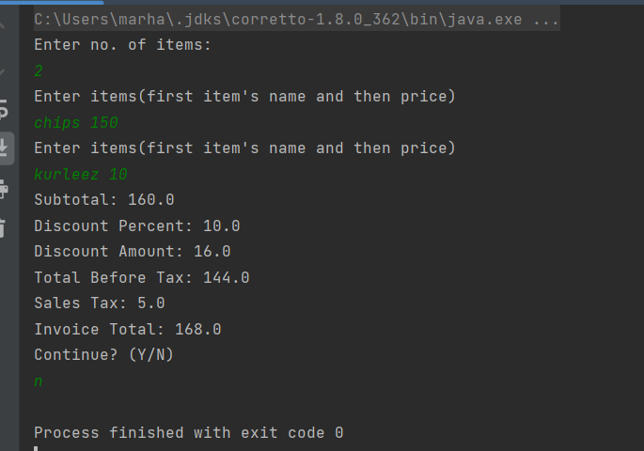
Task 2 Code:
package com.company;
public class Lab2Task2 {
public static void main(String[] args) {
int even=0,odd=0;
for (int i=1 ;i<=100;i++){
if (i % 2 == 0){
even = even + i;
}
else {
odd= odd+i;
}
}
System.out.println("sum of even is: "+ even);
System.out.println("sum of odd is: "+ odd);
}
}

TASK 2 Output:
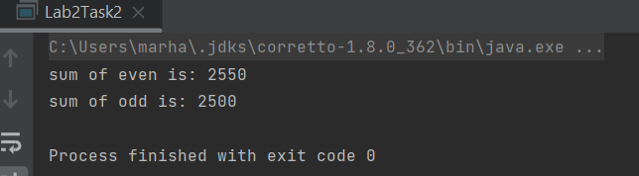
TASK 3 Code:
package com.company;
import java.util.Scanner;
public class Lab2Task3 {
public static void main(String[] args) {
Scanner M = new Scanner(System.in);
System.out.println("input the number u want the table for ? ");
int num = M.nextInt();
for (int i = 1; i <= 10; i++) {
System.out.println("\n" +i*num);
}
}
}

TASK 3 Output:
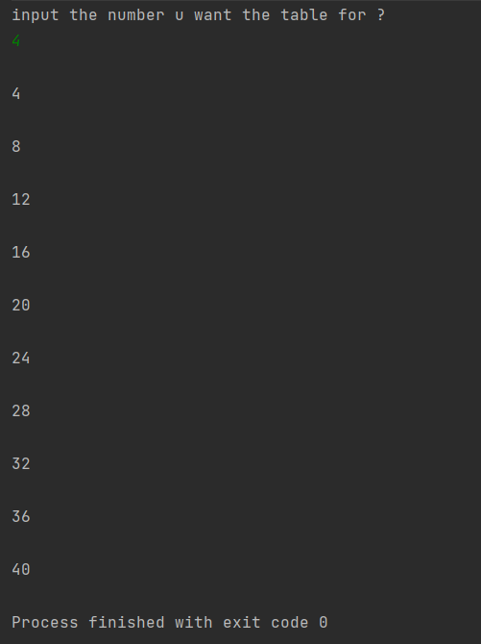
TASK 4 Code :
package com.company;
import java.util.Scanner;
public class Lab2Task4 {
public static void main(String[] args) {
Scanner M = new Scanner(System.in);
System.out.println("how many students are there ?");
int std = M.nextInt();
int pass=0, fail=0, totalmarks =0, avg =0;
for (int i=1;i<=std;i++){
System.out.println("input marks");
int mark = M.nextInt();
if (mark>=60){
pass = pass + 1;
}
else {
fail = fail + 1;
}
totalmarks= totalmarks + mark;
}
avg= totalmarks/std;
System.out.println("the total students were "+std);
System.out.println("the average of students = "+avg);
System.out.println("the students who are fail = "+fail);
System.out.println("the students who passed = "+pass);
}
}

TASK 4 OUTPUT:
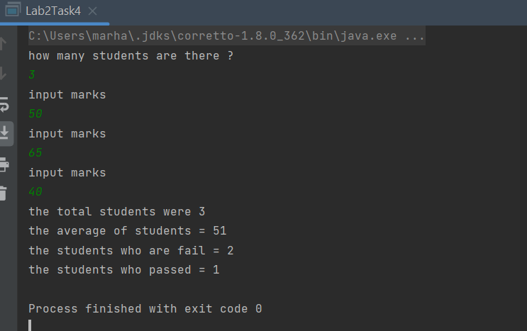

Task 5 Code:
package com.company;
import java.util.Scanner;
public class Lab2Task5 {
public static void main(String[] args) {
String id;
int option;
int amount = 0;
int accBalance = 5000;
char exit ='N';
Scanner s = new Scanner(System.in);
System.out.println("Enter Username: ");
id = s.nextLine();
System.out.println("Enter Password: ");
String PW = s.next();
do {
if (id.equals("arham") && PW.equals("fast123")) {
System.out.println("Correct id and pass");
System.out.println("\tMain Menu ** Welcome to Bank of Pakistan**");
System.out.println("\t\t1- Deposit Money");
System.out.println("\t\t2- Withdraw Money");
System.out.println("\t\t3- Account Status");
option = s.nextInt();
switch (option) {
case 1:
// System.out.println("Account Balance: " + accBalance);
System.out.println("Enter Amount to deposit: ");
amount = s.nextInt();
accBalance = accBalance + amount;
break;
case 2:
System.out.println("Enter Amount to withdraw: ");
amount = s.nextInt();
accBalance = accBalance - amount;
break;
case 3:
System.out.println("Account Balance: " + accBalance);
System.out.println("Last Transaction: " + amount);
break;
default:
System.out.println("Enter Valid option!");
}
System.out.println("Continue? (Y/N)");
exit = s.next().charAt(0);
}
}while (exit == 'Y' || exit == 'y');
}
}

Task 5 Output:
